Proportional Systematic Error
# Source: AI Source: Provided by: [Data Path: Persons Table -> ID Column: 1, Name_En Column: Motasem Essam] -> From: [ChatGPT] on [7/17/2026]
Proportional Systematic Error is a type of systematic error in which the magnitude of the error changes in direct proportion to the size of the measured quantity. Unlike a constant systematic error, which adds or subtracts the same fixed amount from every measurement, a proportional systematic error increases or decreases as the measured value increases.
Proportional systematic errors primarily affect measurement accuracy and are common in instruments with incorrect calibration factors, gain errors, or scale-factor errors.

Definition
# Source: AI Source: Provided by: [Data Path: Persons Table -> ID Column: 1, Name_En Column: Motasem Essam] -> From: [ChatGPT] on [7/17/2026]
Proportional Systematic Error is a systematic measurement error in which the measurement error is proportional to the true or measured value, causing larger quantities to have larger absolute errors.

Purpose of Studying Proportional Systematic Errors
# Source: AI Source: Provided by: [Data Path: Persons Table -> ID Column: 1, Name_En Column: Motasem Essam] -> From: [ChatGPT] on [7/17/2026]
Understanding proportional systematic errors helps to:
- Improve measurement accuracy.
- Detect calibration scale errors.
- Correct instrument gain errors.
- Improve quality control.
- Ensure compliance with measurement standards.
- Increase confidence in measurement results.

Characteristics
# Source: AI Source: Provided by: [Data Path: Persons Table -> ID Column: 1, Name_En Column: Motasem Essam] -> From: [ChatGPT] on [7/17/2026]
Proportional systematic errors:
- Are consistent and repeatable.
- Increase or decrease with the measured value.
- Produce a percentage bias rather than a fixed bias.
- Affect accuracy more than precision.
- Can often be corrected through calibration.

Mathematical Representation
# Source: AI Source: Provided by: [Data Path: Persons Table -> ID Column: 1, Name_En Column: Motasem Essam] -> From: [ChatGPT] on [7/17/2026]
If:
- $T$= true value
- $k$= proportional error factor
- $M$= measured value
then:
$$M=T(1+k)$$
where:
- $k>0$indicates measurements are consistently too large.
- $k<0$indicates measurements are consistently too small.

Example
# Source: AI Source: Provided by: [Data Path: Persons Table -> ID Column: 1, Name_En Column: Motasem Essam] -> From: [ChatGPT] on [7/17/2026]
Suppose an instrument has a +2% calibration error.

True Value | Measured Value | Error
10.00 cm | 10.20 cm | +0.20 cm
50.00 cm | 51.00 cm | +1.00 cm
100.00 cm | 102.00 cm | +2.00 cm
The percentage error remains constant (2%), but the absolute error increases as the measured value increases.

Another example:
# Source: AI Source: Provided by: [Data Path: Persons Table -> ID Column: 1, Name_En Column: Motasem Essam] -> From: [ChatGPT] on [7/17/2026]
A digital scale consistently reads 1% higher than the true mass.

True Mass | Measured Mass
5.00 kg | 5.05 kg
20.00 kg | 20.20 kg
80.00 kg | 80.80 kg

Causes of Proportional Systematic Error
# Source: AI Source: Provided by: [Data Path: Persons Table -> ID Column: 1, Name_En Column: Motasem Essam] -> From: [ChatGPT] on [7/17/2026]
Proportional systematic errors commonly arise from:
Calibration Scale Error
The instrument scale is stretched or compressed.

Gain Error
Electronic instruments amplify signals incorrectly.

Incorrect Scale Factor
The instrument uses an incorrect conversion factor.

Sensor Sensitivity Error
The sensor responds proportionally more or less than intended.

Identifying Proportional Systematic Errors
# Source: AI Source: Provided by: [Data Path: Persons Table -> ID Column: 1, Name_En Column: Motasem Essam] -> From: [ChatGPT] on [7/17/2026]
Proportional systematic errors can be detected by:
- Measuring several certified reference standards across the instrument's measurement range.
- Comparing measurements with calibrated instruments.
- Performing calibration tests at multiple points.
- Plotting measured values against true values and checking whether the slope differs from 1.

Correcting Proportional Systematic Errors
# Source: AI Source: Provided by: [Data Path: Persons Table -> ID Column: 1, Name_En Column: Motasem Essam] -> From: [ChatGPT] on [7/17/2026]
If the proportional error factor is known, the corrected value can be calculated.
For a positive proportional error:
$$\boxed{\text{Corrected Value}=\frac{\text{Measured Value}}{1+k}}$$
Example:
Measured value:
102 cm
Instrument error:
+2%
$$\frac{102}{1.02}=100\text{ cm}$$

Applications
# Source: AI Source: Provided by: [Data Path: Persons Table -> ID Column: 1, Name_En Column: Motasem Essam] -> From: [ChatGPT] on [7/17/2026]
Understanding proportional systematic errors is important in:
- Engineering
- Manufacturing
- Electronics
- Surveying
- Laboratory measurements
- Scientific research
- Metrology
- Quality assurance
- Medical instrumentation

Everyday Examples
# Source: AI Source: Provided by: [Data Path: Persons Table -> ID Column: 1, Name_En Column: Motasem Essam] -> From: [ChatGPT] on [7/17/2026]
Examples include:
- A fuel pump that always dispenses 2% less fuel than indicated.
- A digital scale with a 1% calibration error.
- A voltmeter with an incorrect gain setting.
- A flow meter that consistently measures 3% higher than the actual flow.

Common Mistakes
# Source: AI Source: Provided by: [Data Path: Persons Table -> ID Column: 1, Name_En Column: Motasem Essam] -> From: [ChatGPT] on [7/17/2026]
- Confusing proportional errors with constant errors.
- Assuming repeated measurements eliminate the error.
- Ignoring calibration across the full measurement range.
- Correcting measurements using a fixed offset instead of a scale factor.

Proportional Systematic Error vs. Constant Systematic Error
# Source: AI Source: Provided by: [Data Path: Persons Table -> ID Column: 1, Name_En Column: Motasem Essam] -> From: [ChatGPT] on [7/17/2026]
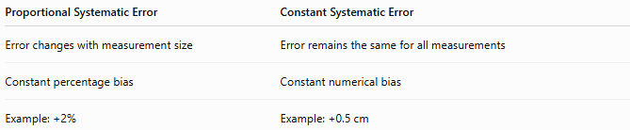
Proportional Systematic Error | Constant Systematic Error
Error changes with measurement size | Error remains the same for all measurements
Constant percentage bias | Constant numerical bias
Example: +2% | Example: +0.5 cm

Proportional Systematic Error vs. Random Error
# Source: AI Source: Provided by: [Data Path: Persons Table -> ID Column: 1, Name_En Column: Motasem Essam] -> From: [ChatGPT] on [7/17/2026]
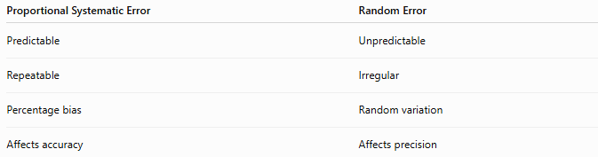
Proportional Systematic Error | Random Error
Predictable | Unpredictable
Repeatable | Irregular
Percentage bias | Random variation
Affects accuracy | Affects precision

Proportional Systematic Error vs. Gross Error
# Source: AI Source: Provided by: [Data Path: Persons Table -> ID Column: 1, Name_En Column: Motasem Essam] -> From: [ChatGPT] on [7/17/2026]
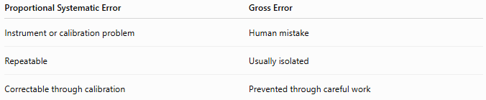
Proportional Systematic Error | Gross Error
Instrument or calibration problem | Human mistake
Repeatable | Usually isolated
Correctable through calibration | Prevented through careful work

Importance
# Source: AI Source: Provided by: [Data Path: Persons Table -> ID Column: 1, Name_En Column: Motasem Essam] -> From: [ChatGPT] on [7/17/2026]
Understanding proportional systematic errors:
- Improves measurement accuracy.
- Produces reliable calibration.
- Enhances manufacturing quality.
- Supports scientific research.
- Ensures compliance with international standards.
- Improves confidence in measurement systems.

Key Points
# Source: AI Source: Provided by: [Data Path: Persons Table -> ID Column: 1, Name_En Column: Motasem Essam] -> From: [ChatGPT] on [7/17/2026]
- A proportional systematic error changes in proportion to the measured value.
- It produces a constant percentage bias, not a constant numerical offset.
- Larger measurements have larger absolute errors.
- Common causes include calibration scale errors, gain errors, incorrect scale factors, and sensor sensitivity errors.
- It can usually be corrected through proper calibration or by applying the appropriate correction factor.

Conclusion
# Source: AI Source: Provided by: [Data Path: Persons Table -> ID Column: 1, Name_En Column: Motasem Essam] -> From: [ChatGPT] on [7/17/2026]
Proportional Systematic Error is a type of systematic measurement error in which the error is directly proportional to the magnitude of the measured quantity. As the measured value increases, the absolute error increases, while the percentage error remains approximately constant. These errors commonly arise from incorrect calibration factors, gain errors, scale-factor errors, or sensor sensitivity problems. Because proportional systematic errors are consistent and predictable, they can usually be identified through multi-point calibration and corrected by applying the appropriate scale correction, thereby improving the accuracy and reliability of measurement systems.

